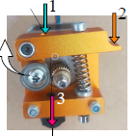
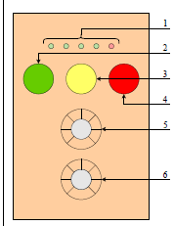


Instructions for Wire-Cutting machine
Set up of the wire in the extruder | Set up:  - Place the spool in the position provided and then pass the wire through the black component on top of the device.  - Remove the plastic cover of the machine and put the wire in the hole at the end of the arrow 1.  - Press the lever (arrow 2) to separate the gear from the bearing.  - Keep pressing the lever, make sure the wire pass through between 2 wheels and then through the nozzle (arrow 3)  - Close the cover and select the required cut particle size (5) and the length of wire remained in the spool (6) on the user interface
User interface of the machine  User interface controls  - Progress of the cutting program  - Start button  - Pause button  - Stop button  - Particle’s length  - Spool’s length | How to use the machine?  - To start the program, press the Start button (2), the entire wire of the coil will be cut.  - For any reason, if the user wants to pause the program, press the Pause button(3). To restart the device, press the Start button (2) again.  - To stop the program completely and reset the positioning, press the Stop button (4).  - The progress of the cutting program is indicated by the LED (1) on top. (Each LED represents to 20% of the progress). When the end of the LED is on, it means that the cutting program is done.  Notice:  - The buttons are not very sensible, make sure to remain pressing the button for a couple of seconds.  - When a cutting program finish and changing to the other particle’s length and spool length, make sure to press the Stop button (4) to initialize the program first.
- Don’t start the machine if the cover is not closed.
- Don’t open the cover if the machine is running
- Be careful to plug the power supply.

